**Project Design Phase-II**

**Technology Stack (Architecture & Stack)**

|  |  |
| --- | --- |
| Date | 27 JUNE 2025 |
| Team ID | LTVIP2025TMID31213 |
| Project Name | EDUTUTOR-AI-PERSONALIZED-LEARNING-  WITH-GENERATIVE-LMS-INTEGRATION |
| Maximum Marks | 4 Marks |

**Technical Architecture:**

The Deliverable shall include the architectural diagram as below and the information as per the table1 & table 2

**Example: Order processing during pandemics for offline mode**

**Reference:** [**https://developer.ibm.com/patterns/ai-powered-backend-system-for-order-processing-during-pandemics/**](https://developer.ibm.com/patterns/ai-powered-backend-system-for-order-processing-during-pandemics/)

|  |  |  |  |  |  |  |  |  |  |
| --- | --- | --- | --- | --- | --- | --- | --- | --- | --- |
| **S.No** | | **Component** | **Description** | | | | **Technology** | | |
| 1. |  | User Interface | How Web | user  UI, | interacts with application Mobile App, Chatbot etc. | e.g. | HTML,  React | CSS, Js etc. | JavaScript / Angular Js / |
| 2. | | Application Logic-1 | Logic for a process in the application | | | | Java / Python | | |
| 3. | | Application Logic-2 | Logic for a process in the application | | | | IBM Watson STT service | | |
| 4. | | Application Logic-3 | Logic for a process in the application | | | | IBM Watson Assistant | | |
| 5. | | Database | Data Type, Configurations etc. | | | | MySQL, NoSQL, etc. | | |
| 6. | | Cloud Database | Database Service on Cloud | | | | IBM DB2, IBM Cloudant etc. | | |
| 7. | | File Storage | File storage requirements | | | | IBM Block Storage or Other Storage Service or Local Filesystem | | |
| 8. | | External API-1 | Purpose of External API used in the application | | | | IBM Weather API, etc. | | |



**Table**

**-**

**1**



**:**



**Components**



**&**



**Technologies:**

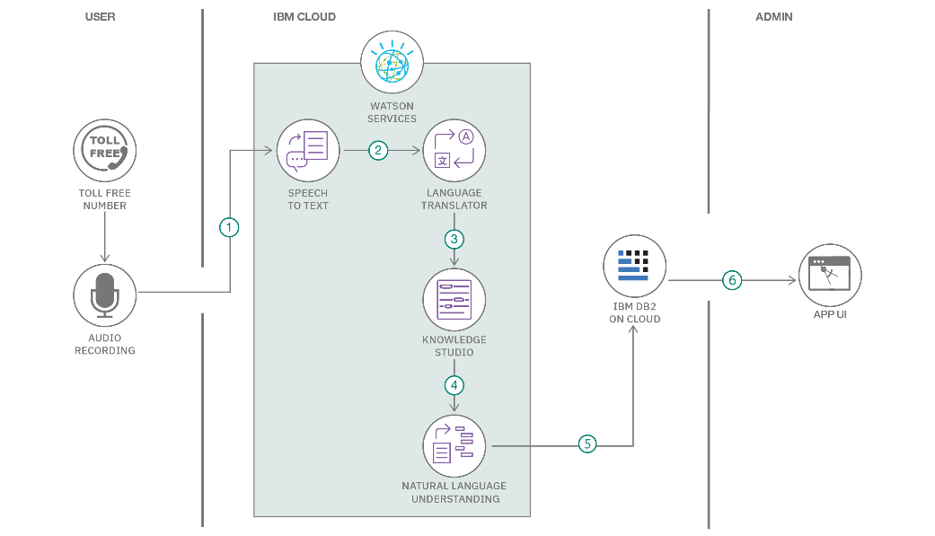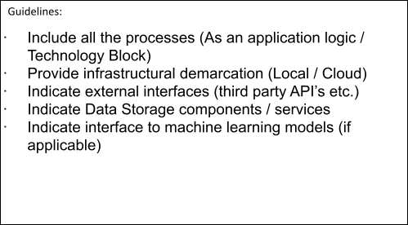

|  |  |  |  |
| --- | --- | --- | --- |
| 9. | External API-2 | Purpose of External API used in the application | Aadhar API, etc. |
| 10. | Machine Learning Model | Purpose of Machine Learning Model | Object Recognition Model, etc. |
| 11. | Infrastructure (Server / Cloud) | Application Deployment on Local System / Cloud Local Server Configuration:  Cloud Server Configuration : | Local, Cloud Foundry, Kubernetes, etc. |

|  |  |  |  |
| --- | --- | --- | --- |
| **S.No** | **Characteristics** | **Description** | **Technology** |
| 1. | Open-Source Frameworks | List the open-source frameworks used | Technology of Opensource framework |
| 2. | Security Implementations | List all the security / access controls implemented, use of firewalls etc. | e.g. SHA-256, Encryptions, IAM Controls, OWASP etc. |
| 3. | Scalable Architecture | Justify the scalability of architecture (3 – tier, Microservices) | Technology used |
| 4. | Availability | Justify the availability of application (e.g. use of load balancers, distributed servers etc.) | Technology used |

**Table-2: Application Characteristics:**

|  |  |  |  |
| --- | --- | --- | --- |
| **S.No** | **Characteristics** | **Description** | **Technology** |
| 5. | Performance | Design consideration for the performance of the application (number of requests per sec, use of Cache, use of CDN’s) etc. | Technology used |

**References:**

[**https://c4model.com/**](https://c4model.com/) [**https://developer.ibm.com/patterns/online-order-processing-system-duringpandemic/**](https://developer.ibm.com/patterns/online-order-processing-system-during-pandemic/) [**https://www.ibm.com/cloud/architecture**](https://www.ibm.com/cloud/architecture) [**https://aws.amazon.com/architecture**](https://aws.amazon.com/architecture) [**https://medium.com/the-internal-startup/how-to-draw-useful-technical-architecture-diagrams-**](https://medium.com/the-internal-startup/how-to-draw-useful-technical-architecture-diagrams-2d20c9fda90d)

[**2d20c9fda90d**](https://medium.com/the-internal-startup/how-to-draw-useful-technical-architecture-diagrams-2d20c9fda90d)